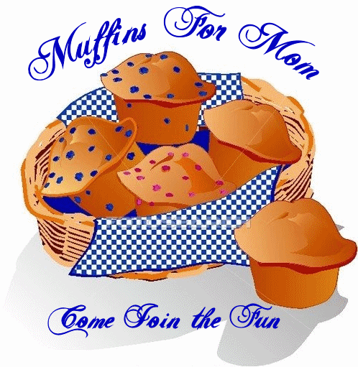

As Mother’s Day approaches, many teachers will be looking for great ideas for gifts children cam make and give to their mothers. Moms are not very excited about large dough shapes fashioned into stylish earrings that cause their earlobes to rest on their shoulders by the end of worship. Mother’s are more interested in spending time with their child.

Ask Sunday School teachers to host a “Muffins for Mom” time before or during Sunday School. Teachers will need muffins for each child and mother (grandmother) and some juice or water. If mothers come during the last half of the SS class time, the kids could prepare a pretty table for the food and drinks before they arrive. Each mother can be seated while the child serves. Then the child could enjoy a muffin with their mother while the teacher leads the group time and Bible story. Children can prepare cards before their mom arrives. Encourage them to write or draw things that they love about their mother. Give time for kids to present the cards to their mother or read them to the class as part of the presentation. Encourage the mother and child to pray together before they leave. Mothers will feel loved and special without worrying about their earlobes being stretched.

*Note—Be sensitive to children without a mother present. Encourage them to invite women they respect and appreciate. Consider asking mothers to attend whose children are not present so a child may adopt them for this day. This might be a terrific way for children to be involved in outreach. Follow up with all guests with a nice card of appreciation for their attendance.

Mark Jones
Childhood Ministry Specialist
Baptist General Convention of Oklahoma

